# Pedunculate Oak

## Dair ghallda (Quercus robur)

Once widespread throughout Ireland, centuries of harvesting, with few trees being replaced, means that truly native oak can be hard to find, though there are small woods in most counties. Very often, semi-natural oak woodlands contain a proportion of birch and ash, with hazel, holly and rowan scattered throughout the understorey. Oak has been harvested for its fine timber for centuries and is much prized for its visual qualities and durability. It is commonly used in the making of furniture, for veneers and in the manufacture of casks. The male flowers of oak are borne on rather inconspicuous catkins, which come out just before the leaves, but the seeds – acorns – are far more obvious. Oak trees do not produce a good crop every year, so it is worth gathering plenty in a good year.  
The pedunculate or English oak is also considered to be a native tree. It is generally associated with heavy lowland soils and can withstand wet soil in winter. These oak woods are found in Charleville, Co. Offaly and Abbeyleix, Co. Laois.

Mature tree –

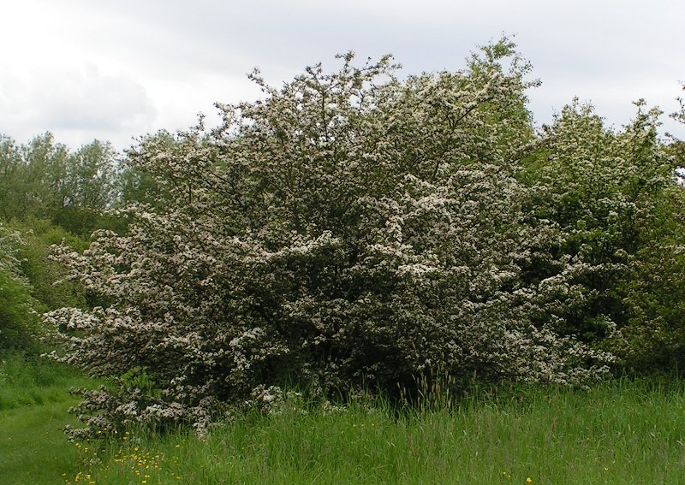

**Flowers and Fruit**

The flowers are long yellow hanging catkins, its fruit, commonly known as acorns, are 2–2.5cm long. As they ripen, the green acorn takes on a browner colour.

Flower

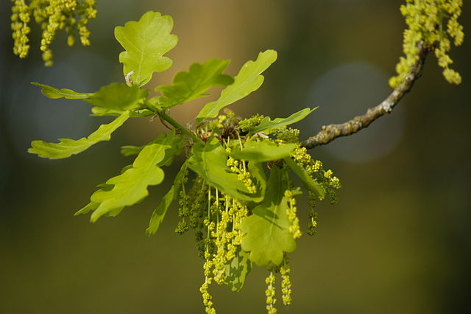

Acorns

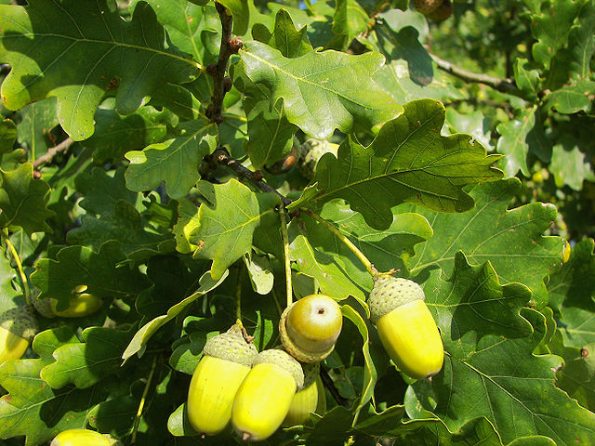

### **Bark**

Young plants have a smooth, shiny bark, which darkens with age. The mature bark is grey and fissured.

Mature Bark

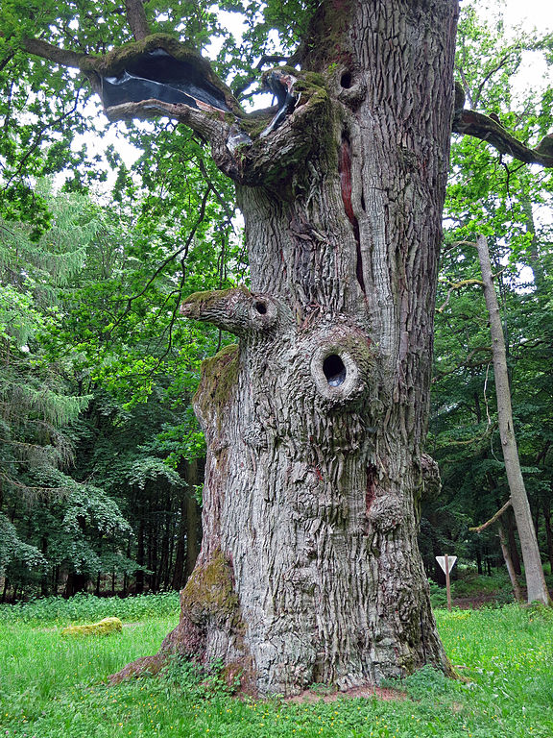

### **Leaves**

**The leaves are** about 10cm long with 4-5 deep lobes with smooth edges. Leaves have almost no stem and grow in bunches.

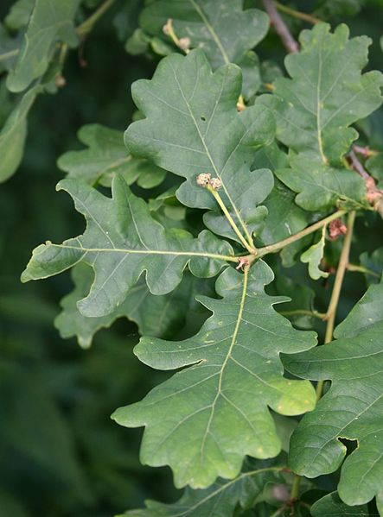

Botanical Illustration

